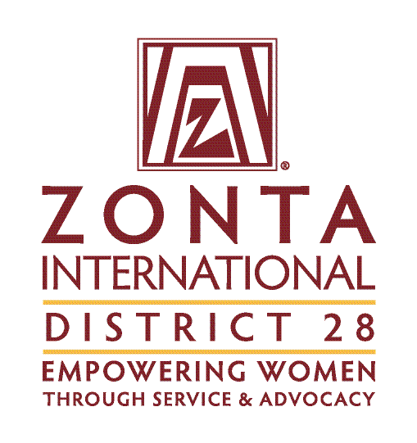

District 28 STEM Award – Evaluation form

APPLICANT: ______________________________________________________
EVALUATOR: _____________________________________________________

 | Item | Possible points | Applicant’s points
1 | Personal experience in STEM  - Why did you choose this STEM degree programme?  - What is your motivation?  - What career goals do you have?  - What position do you hold in the university environment as a woman?  - What impact do you want to make in your field?  - Tell us a short anecdote where you had to overcome a hurdle in your degree programme for the reason of being a woman. | 50
2 | Social commitment  - Volunteering commitment to women and girls  - Type of volunteering activity/activities  - Target groups  - Duration and scope  - Your motivation for the activity/activities | 30
3 | Role model / Leadership  - Does the applicant act in her academic/professional environment as a „role model“?  - Goals achieved  - Does the applicant assume responsibility for leadership tasks in her academic/professional environment?  - Goals achieved  - Sustainability of the goals | 20
 | Maximum points | 100
Comments

