**District Conference 26 to 29 September 2025**

**Report Chair: MEMBERSHIP**

**Zelinda Legge**

As representative of D28 I attended the International Membership Committee meetings.

During these meetings I exchanged ideas about the situation of membership in my club and other clubs I know of, with the Chair Deb Lal as also with my attending collegues Lt. Governor.

Each one of these meetings had a theme to be developed, from these conversations we were able to reach some interesting achievement about the strategies to raise membership in our clubs and more of this to retain our club members.

We were called to answer some surveys in which we aknowledge that new member have to be welcomed in a pleasant manner have to find in the club a friendly environment, people willing to listen respectfully at their opinions altough they are “the last arrived” .

To be retained they have to be involved as soon as possible in club activities as well as in ZI activities, they have to be informed about the impact that ZI has all over the world via our participation in ONU and EU Committees.

And last but not least we have to have fun, in common opinion it is very important to share time of pure fun too, with our club members.

So said, with a rapid overview on the trend of membership since 1994, we can see the ZI membership decrease at a growing rate so that we lost about 3000 members every 10 years until 2020 and about 4000 members during the last 5 years.

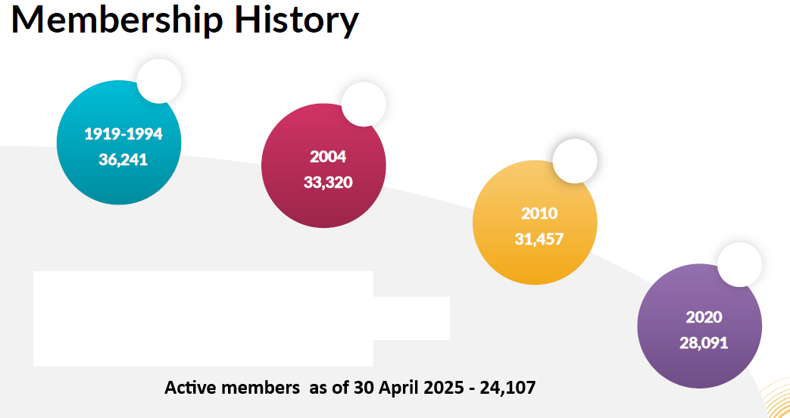

In the next pages you see some statistics about the last year, we have a comparison made over the same period of the last fiscal year, and we can see the global situation of member and club in the entire zontian world.

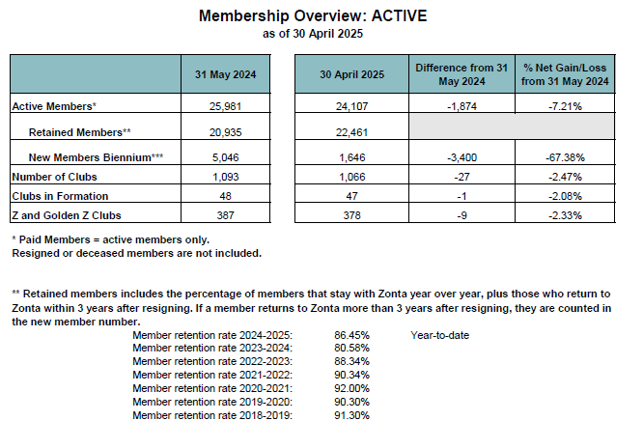

One positive figure is the retaining percentage, id est, the percentage of members that remain in Zonta year-after-year, it is dropped from 91% in 2018 to 80% in 2024 and now is newly raised to 86,45%.

Speaking about our District this is the situation of districts membership compairing same period of the last years, 31 of May 2024 versus 30 of April 2025 we lost 72 members, the 5,36% of our membership and in the same time we lost 1 club.

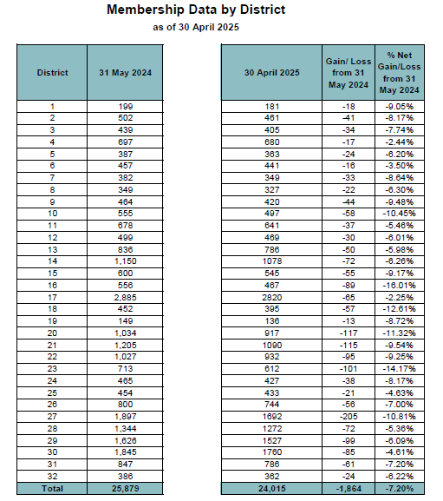

Therefore our most important task is to increase membership not only finding new members, but make member to stay, the membership committe did realise this work on the motives to stay or no-stay in zonta that I found very close to the reality as I know it from my club and my Area.

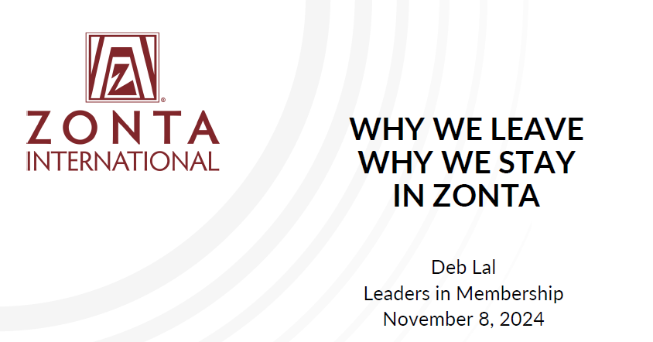

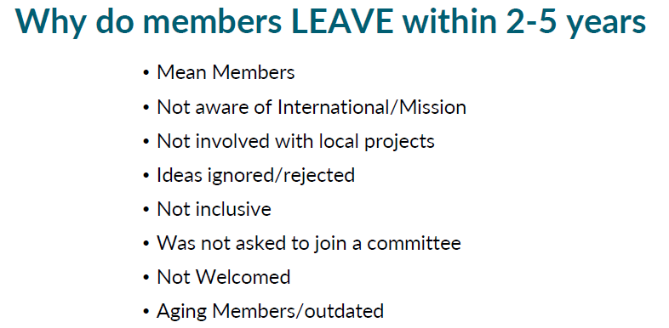

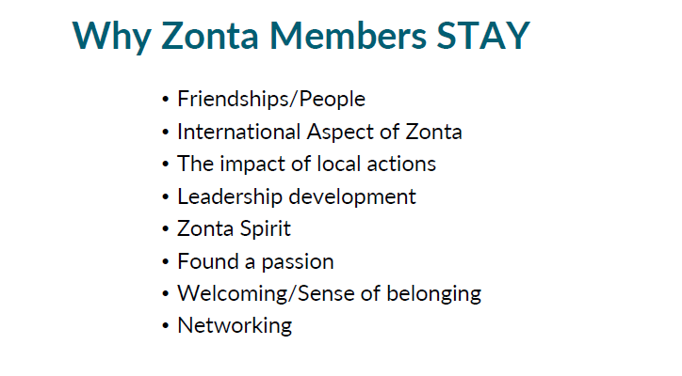

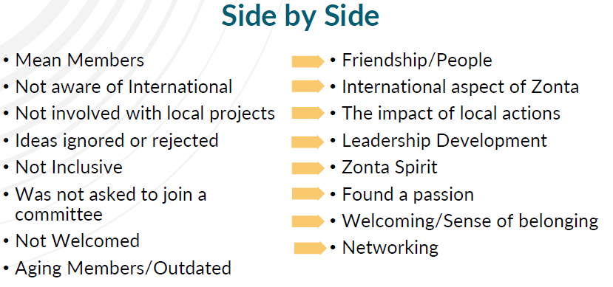

I think it can be a good tool to have on hand when we have to manage the new members arrival without upsetting the balance of clubs, I here used parts of a presentation that was showed during a meeting of MS Committee, as is indicated by the name of Deb Lal in the first slide.

In MyZonta Tools- Club creator tools, can be found some manuals and best practice to ask new members to join as well as to ideas to retain members and obviously some tools for creating new clubs.

I also happened to attend some meetings of Club Creators during which I had some interesting tips from the Chairs Ann Van Erp (International) and Regine Clays (Europe), they developed some stratiegies to find the necessary members to open a new club, their advice is to organise a meeting, an apero, a conference and so on, inviting all local preminents personalities that can be interested in Zonta Mission, to present ZI asking the attending people to join Zonta, do invitations by cards, e-mails or use posts on social media.