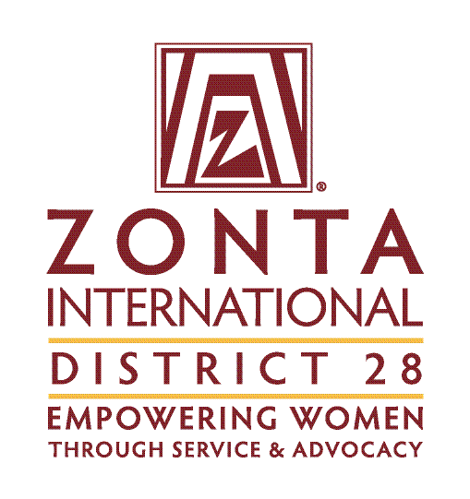

D28 STEM Award - Application

Description
Women are still heavily underrepresented in the subjects of Science, Technology, Engineering and Mathematics (STEM). We need to support women role in technological development, bringing women’s prospective into STEM fields will be crucial for shaping a better and more inclusive world. As part of its mission to advocate for women empowerment Zonta International-District 28 is offering an award to encourage women to pursue education and leadership roles in STEM professions.

Award
Zonta International District 28 will award three prizes to very talented young women pursuing a career in STEM fields.
1st prize: 5000 USD Zonta International
2nd prize: 2000 EUR District 28
3rd prize: 1000 EUR District 28

Who is Eligible?
Women of any age, pursuing a program in science, technology, engineering or mathematics (STEM) at an accredited university/college/institute, who demonstrate outstanding potential in the field and are living or studying in the Zonta district 28 region are eligible. Online students are also eligible to apply if enrolled at an accredited university/college/institute.
Students must be enrolled in at least the second year of an undergraduate program through the final year of a master's program at the time the application is submitted to the local Zonta club.

Rewarding criteria: Good performance in STEM subjects; pioneering role or role model function in the corresponding STEM study programme; social commitment in favour of women, girls or other persons.

Note: ZI demands that applicants for the ZI Women in STEM scholarship must be in school at the time the ZI scholarship funds are disbursed and must not graduate before April 2024.

icon stem: vecteezy.com

Two-stage application procedure
Academic performance is assessed at the club level, a panel of experts from the accredited university/college/institute may be involved. Subsequently, the performance in the field of "Women in Science and Society" is assessed at the district level by committed, experienced Zontians of the district, preferably with an academic educational background.

A) Club level:
- The club appoints a jury of experts, if needed in consultation with an accredited university/college/institute.
- This jury evaluates applications in terms of academic quality (academic score, outstanding achievement in tech-related subjects). It applies a criteria grid. In addition, it takes references into account.
- The jury formulates a recommendation for the attention of the club.

B) District level
- The club submits an application according to the district's specifications.
- The district jury will judge the applications according to the criteria in the application.

Timing:
- By 1. Aug. 2023 Clubs submit applications to D28 governor.
- By 1. Sept. 2023 Districts submit district winners to ZI
- Nov. 2023 Official announcement of ZI winners

Application Form for Zonta D28 STEM Award
This form is to be completed by the club. We recommend cooperation with the applicant.
Please return it by 1. August 2023 to Governor Christine Dersch cdersch.zonta@mail.de

Zonta Club
Name: __________________________________
Area: __________________________________
Contact person / responsible person of the club in STEM:
__________________________________________________________________________________
Email address: ______________________________________________________________________
Telephone: _____________________________________

Applicant
Name (Family / First): _______________________________________________________________
Email address: _______________________________________________________________
Telephone: _____________________________
Permanent mailing address: ________________________________________________________
Birth date: _____________________________
Name of university/college/institute currently attending: __________________________________________________________________________________
Current year of study: _____________________________
Major/field of study: _______________________________________________________________
Degree sought: ___________________________________
Expected graduation date (month/year): _______________

Data Protection
Zonta Club and Zonta District 28 take the security of your data seriously. We will never sell, trade, or rent your personal information provided in this application to third parties. By submitting this application, you agree to the use of your data in accordance with the Privacy Policy and Publicity Authorization Form contained in the application documents (see page at the end of the application).

Recommendation letter of the club
Please explain why the applicant convinced the club jury of her academic qualities in the field of STEM.
Not exceed 800 words

Signature of responsible person of the club in STEM  (Insert image of your signature or print, sign and scan this page.) |  | Date

Please print your name

Personal information and goals of the applicant
1. Experience in STEM
- Why did the applicant choose this STEM degree program?
- What is the applicant's motivation?
- What are the applicant's career goals?
- What is the applicant's position as a woman in the university environment?
- What impact does the applicant want to make in her field?
- Tell us a brief anecdote in which the applicant had to overcome a hurdle in her degree program because she is a woman.
not exceed 500 words

2. Applicant's social commitment
- Volunteering commitment to women and girls
- Type of volunteering activity/activities
- Target groups
- Duration and scope
- Applicant’s motivation for the activity/activities
not to exceed 300 word

3. Role model / Leadership
- Does the applicant act as a "role model" in her academic/professional environment?
  - Goals achieved
- Does the applicant assume responsibility for leadership tasks in her academic/professional environment?
  - Goals achieved
  - Sustainability of the goals

not to exceed 200 word

Applicant’s Signature (Insert image of your signature or print, sign and scan this page.) |  | Date

Please print your name

___________________________________________________________________________________________________

Zonta D28 STEM Award

Privacy Policy and Publicity Authorization
Zonta Club and the Zonta District 28 are committed to honoring the privacy and wishes of all of our Zonta D28 STEM Award recipients at all times. In order to do this, please read the following information carefully and indicate your agreement as appropriate.

- Most data collected by Zonta Club and the Zonta district 28 is used only to help Zonta better serve its Award recipients. It is our general policy to collect and store only personal information that our recipients knowingly provide. Zonta does not sell, trade, or rent your personally identifying information to third parties. We take reasonable measures not to disclose personally identifying information about you.
I have read the above paragraph and agree to the Terms and Conditions therein.

- From time to time, Zonta Club and the Zonta District 28 conducts various marketing activities to promote the Zonta D28 STEM Award Program. In addition, to ensure Zonta’s ability to fund the Awards, the Zonta district 28 may from time to time provide information to donors to the Zonta D28 STEM Award about recipients of their donations. Zonta retains the right to use your name, photograph and biographical information to promote the Zonta D28 STEM Awards in various promotional materials, including the website.
I have read the above paragraph and agree to the Terms and Conditions therein.

Signature (Insert image of your signature or print, sign and scan this page.) |  | Date

Please print your name

